1. Open ShopPAK  
   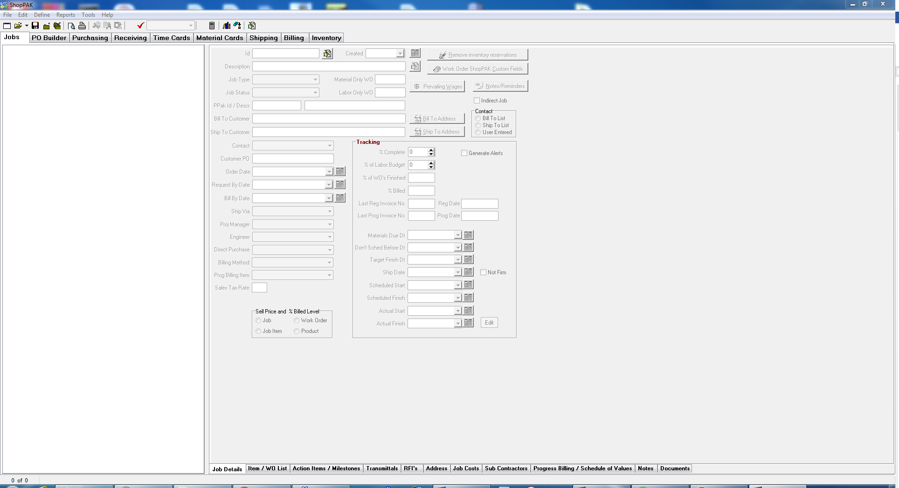
2. Open Remedial WO  
   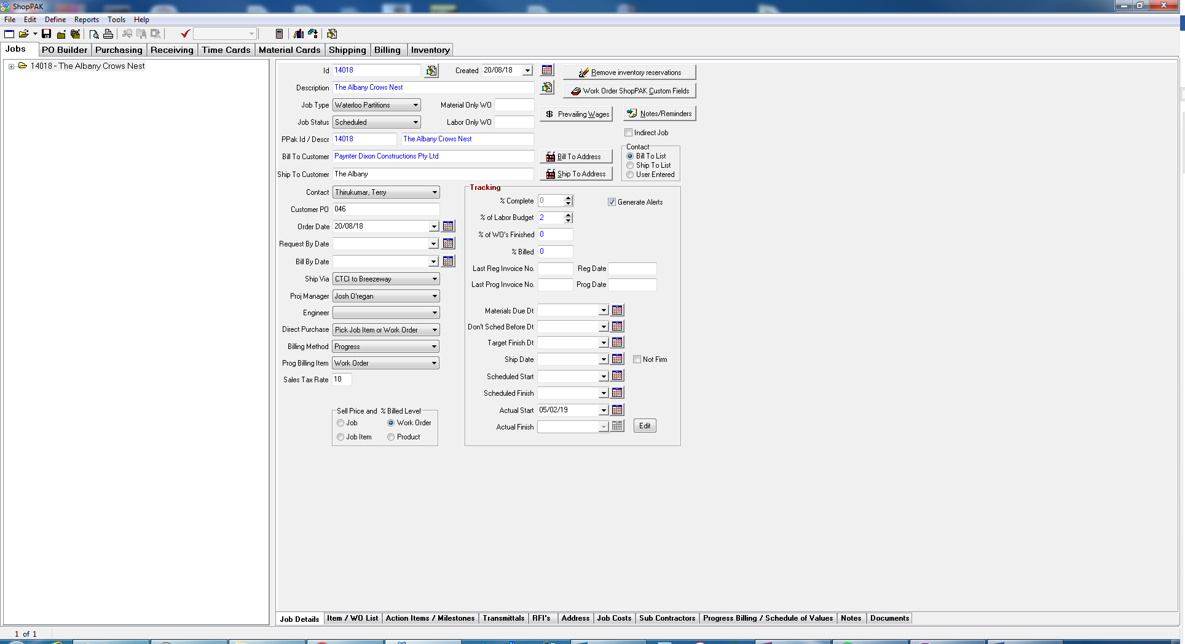
3. Open Action Items / Milestones tab  
   
4. Ensure that the milestones have been selected at the Work Order level.  
   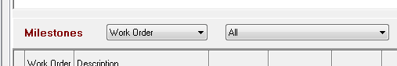
5. If this is a new order follow the below instructions to copy the Milestone Template. If this is further work for an existing order and the milestone template has already been copied then skip to 10.
6. Left click on top of Milestones grid to open menu  
   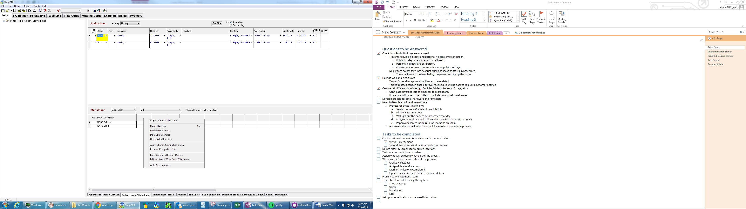
7. Select Copy Milestones Template  
   
8. Select the Cubicles, with yes in the scoreboard column. It is important to select the correct template as Scoreboard will only recognize one template  
   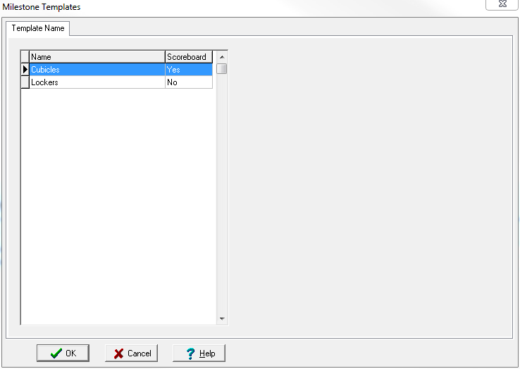
9. Milestones have been populated, ready for dates to be set.  
   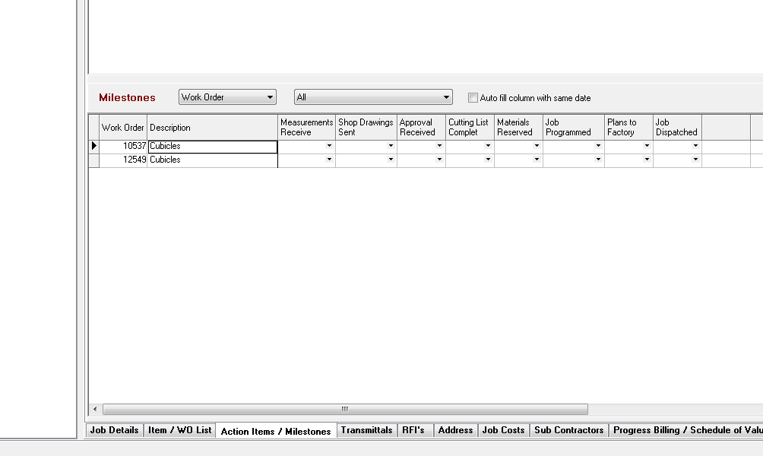
10. Right click the row for this Remedial WO  
    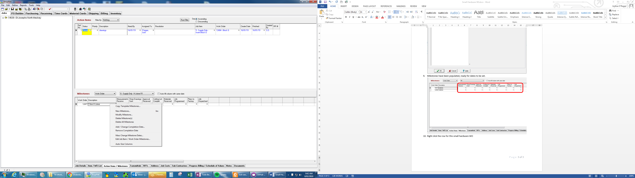
11. Click Edit Job Item / Work Order Milestones  
    
12. Click Adjust Job Item/WO Wait Days  
    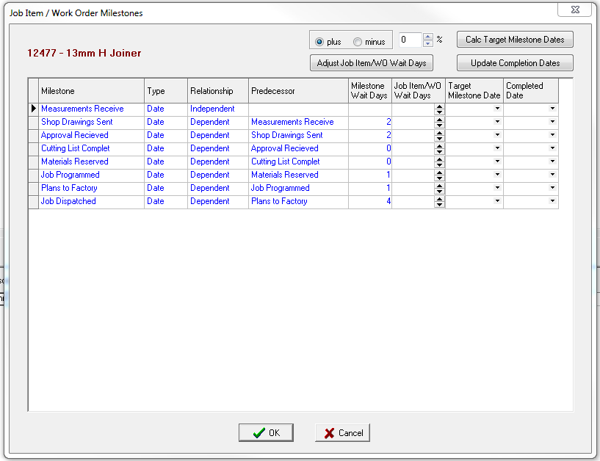
13. Set the Job Item/WO Wait Days to 0 for the following Milestones:  
    For Panels:
    * Shop Drawings Sent = 0
    * Approval Received = 0
    * Cutting List Complete = 0
    * Materials Reserved = 0
    * Job Programmed = 1
    * Plans to Factory = 1
    * Job Dispatched = 3

For Hardware:

* + Shop Drawings Sent = 0
  + Approval Received = 0
  + Cutting List Complete = 0
  + Materials Reserved = 0
  + Job Programmed = 0
  + Plans to Factory = 1
  + Job Dispatched = 1

Note: If there are extended timeframes for the remedial items (eg. Slow to manufacture, parts ordered in, etc.) then increase the Job Dispatched Wait days be a corresponding amount.  
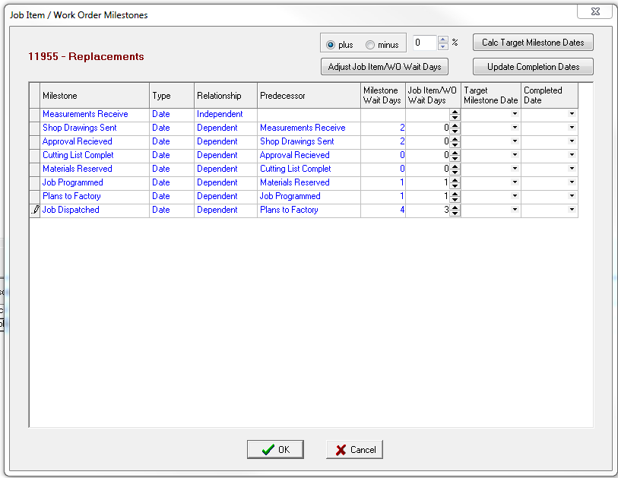

1. Set Target Milestone Date of Measurements Received to Today’s Date  
   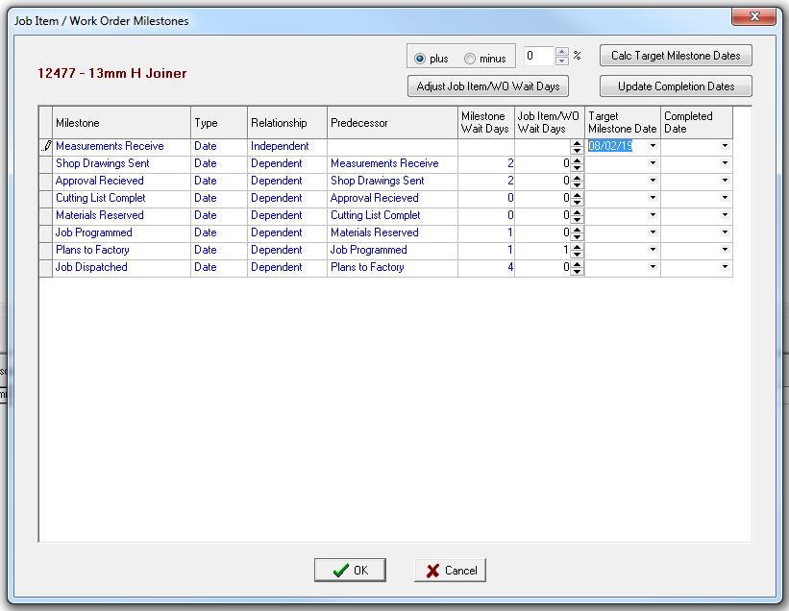
2. Click Calc Target Milestone Dates  
   
3. Skip Saturday and Sunday  
   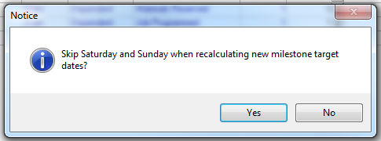
4. Highlight all Milestones to Materials Reserved for Panels, or Job Programmed for Hardware by selecting them in the LH grey column  
   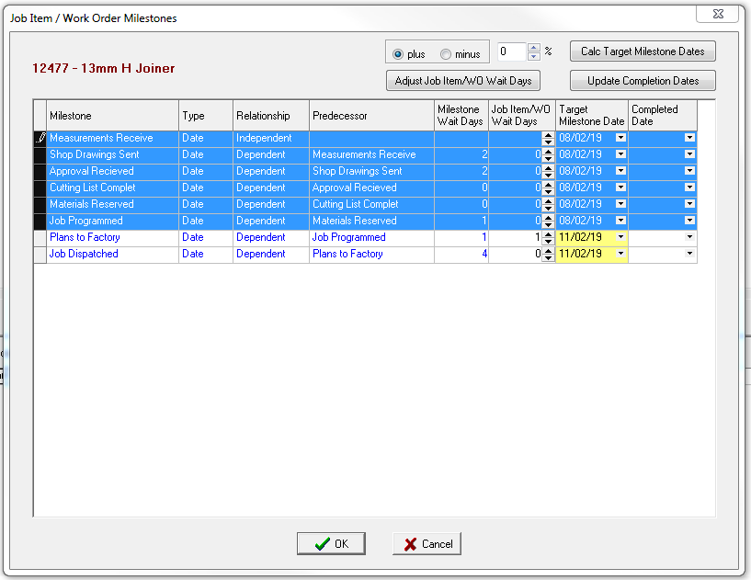
5. Click Update Completion Dates  
   
6. Select “Enter completion date to be used” and select today’s date  
   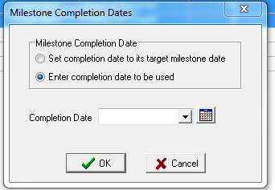
7. Select OK to confirm date to be used.  
   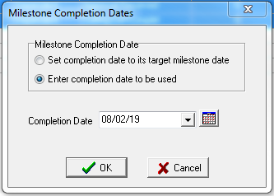
8. All milestone dates are now set up. Click OK to save the changes.  
   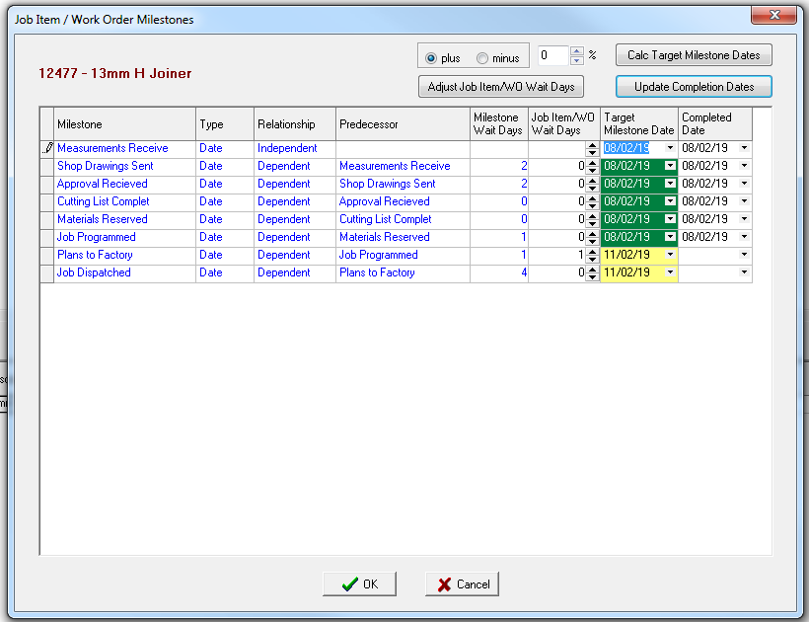
9. WO can continue processing & manufacture now.  
   